Predicting the advent of Human Level Machine Intelligence using Game Tree Complexity

When predicting advances in AI, researchers favour qualitative methods. I think this is for two reasons. Firstly, Intelligence is a very loosely defined concept, and it manifests in very different ways in machines and humans. It would be difficult to ascribe it to a single scalar value. Secondly, we are yet to develop AGI (artificial general intelligence) meaning all existing AI is “narrow”. This means it is designed to be bespoke to a particular task making it very hard to compare with other AI, similarly to how one would struggle to compare an Artist’s intelligence with a Mathematician’s. In addition, advances in AI development are often reliant on unexpected breakthroughs and a combination of different factors. For example, evolutionary computing is a machine learning technique that mimics evolution in nature to train AI. Although “This field was pioneered independently in the 1960s by Fogel et al. 1966, Holland 1975, Rechenberg 1973.” <https://www.sciencedirect.com/topics/computer-science/evolutionary-computation#:~:text=Evolutionary%20computation%20is%20another%20field,%2C%20Holland%201975%2C%20Rechenberg%201973>.

It was not considered viable because it required high processing power which would have been infeasible at the time, so it was overshadowed by gradient based learning which is less resource intensive. However, recent advances in computing power mean that evolutionary computing can now match or even outperform gradient based learning.

<https://deepmind.com/blog/article/how-evolutionary-selection-can-train-more-capable-self-driving-cars>

<https://eng.uber.com/deep-neuroevolution/>

As a result of AI development’s unpredictable nature, studies that try to predict advances in this field use qualitative methods. For example, this study conducted by the FHI (Future of Humanity Institute) where experts were asked to make predictions about the advent of HLMI (Human Level Machine Intelligence). However due to the wide variety of opinions they received a large spread of results making it difficult to draw conclusions from the data.

<https://www.kurzweilai.net/machines-will-achieve-human-level-intelligence-in-the-2028-to-2150-range-poll>

This points towards a need for a quantitative method to produce a more conclusive result. One example of this is the use of Moore’s law to inform AI predictions. Moore looked at the number of transistors in cutting edge processors throughout history and “that the number of transistors per silicon chip doubles every year.”

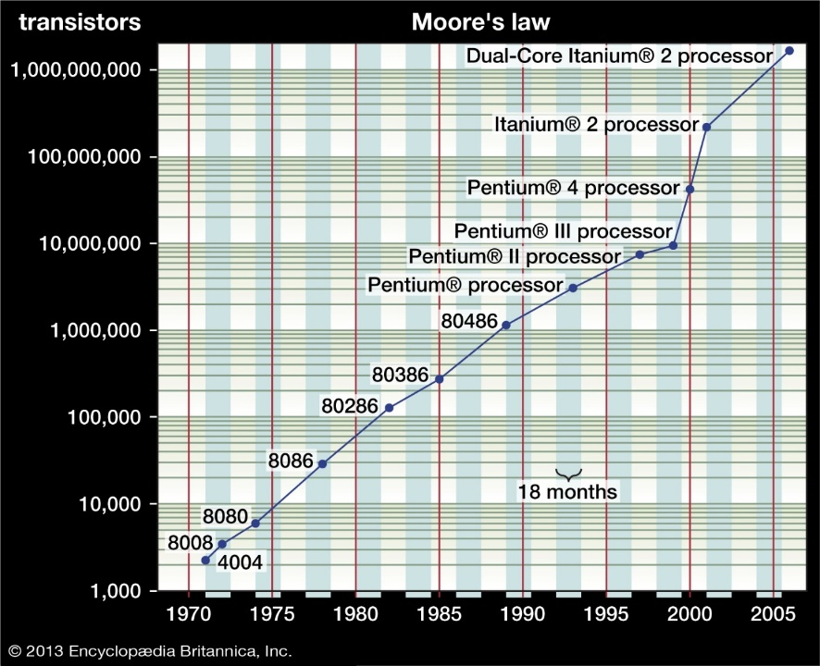

<https://www.britannica.com/technology/Moores-law>

Although this does suggest an exponential trend in the progress of AI because processing power is a factor, it is not enough by itself to inform predictions about the future of AI because it is dependent on many more things for example the different ways in which this processing power is utilised.

For example, in 1988, Victor Allis wrote a program that perfectly plays Connect 4. He combined the processing power of the computer with “a set of strategic rules with which one of the players will never lose.” However for more complex games a set of strategic rules cannot be calculated by a human so easily therefore computer scientists applied the current processing power to machine learning so that the computer could devise these rules itself. However, machine learning can take different forms as we have discussed earlier in comparing gradient-based techniques to evolutionary techniques and it is very hard to predict what form of machine learning will be used for future AI if any form of machine learning is used at all. Therefore, I instead we should look at what they are able to accomplish.

This paper proposes a method based on past instances of an AI matching or surpassing human level play at strategy games. The significance of this achievement will be measured by the GTC (game tree complexity) of said game.

The first question we must answer is ‘What is the significance of an AI surpassing a human at a game?’ and ‘How does this relates to HLMI.’

Strategy games are essentially simulated decision-making scenarios. As games get more complex, they become more representative of the decision making necessary for real life scenarios. DeepMind have used this reasoning to inform what goals to tackle in their AI research stating that “games with increasing complexity … capture different elements of intelligence required to solve scientific and real-world problems.” Therefore, “Games have been used for decades as an important way to test and evaluate the performance of artificial intelligence systems.” Open AI have expressed a similar sentiment saying that “The long-term goal of artificial intelligence is to solve advanced real-world challenges.” And that “Games have served as stepping stones along this path for decades.” As game complexity increases, the AI capable of mastering these games draw closer to the intelligence needed to function in the real world. Therefore, assuming AI progresses at a steady rate, we can observe the level of GTC that AI is capable of handling over time and extrapolate forward to when it will be capable of operating in an environment as complex as the real world, being at ‘human level intelligence’.

<https://deepmind.com/blog/article/alphastar-mastering-real-time-strategy-game-starcraft-ii>

<https://arxiv.org/pdf/1912.06680.pdf>

This begs the question of how to measure the complexity of a game. Combinatorial game theory has many ways of measuring the complexity of games and typically these apply to turn based games but can be applied more generally if we treat time discretely. One such measure is state-space complexity (SSC) which looks at the number of possible positions a game has. However, this is not particularly useful when judging the difficulty of playing a game, for example, noughts and crosses on an infinite board has an infinite (SSC) but is always won in three moves by the starting player (assuming perfect play). A better metric is GTC. If a single game were represented as a tree where the root node is the initial position and each nodes’ children are the positions that could result after a move is made from that position, the number of nodes in this tree would be the GTC.

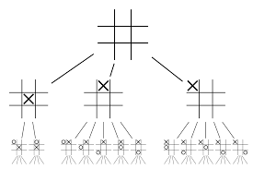

Visualization of noughts and crosses’ game tree.

<https://en.wikipedia.org/wiki/Game_tree>

The actual GTC is very difficult to calculate because it would require analysing every single position. Instead, we can obtain a good approximation using the following formula:

$$GTC=b^{d}$$

Where ‘*b’* is the branching factor (the average number of moves possible on any given turn) and ‘*d’* is the duration (the length of the game in turns).

As games grow more complex, fully searching this tree quickly becomes intractable. For example, in Go there are on average 250 possible moves on any turn and the average length of a game is 150 turns. Therefore, it has a GTC of 10360 which is greater than the number of protons needed to fill the universe.

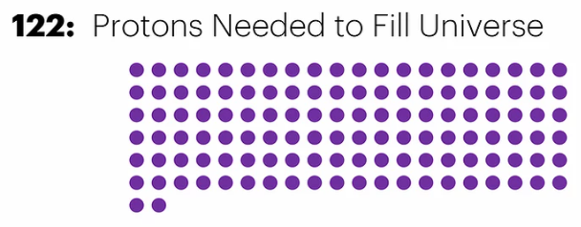 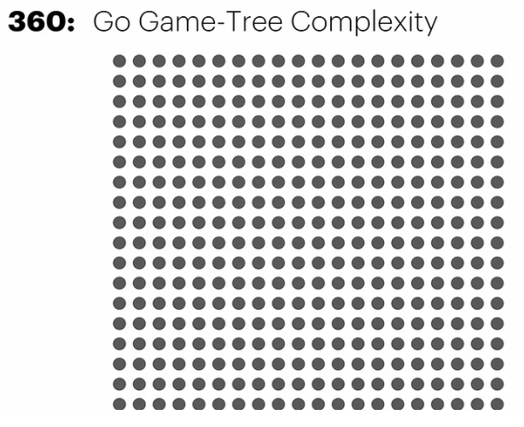

<https://www.pipmodern.com/post/complexity-state-space-game-tree>

It would be inefficient for an AI to consider the whole game tree and it would need a way of determining whether a branch is worth exploring.

However, this method still approximately compares the number of positions an AI would realistically have to consider to play the game successfully, so it does tell us about the relative difficulty of AI achievements.

Until now GTC has only been applied to turn based games. To strengthen our prediction, we will extend our calculation of GTC to RTS (real time strategy) games where players make moves simultaneously. Statistics relevant to GTC have been calculated in academic papers analysing RTS games but GTC has never been explicitly calculated so we shall do that.

In RTS games a turn is replaced by the smallest unit of time in which a player can take an action so the duration will be the length of the game divided by this unit of time. However, on each turn both players make a move so the branching factor will have to include every possible combination of moves from each player.

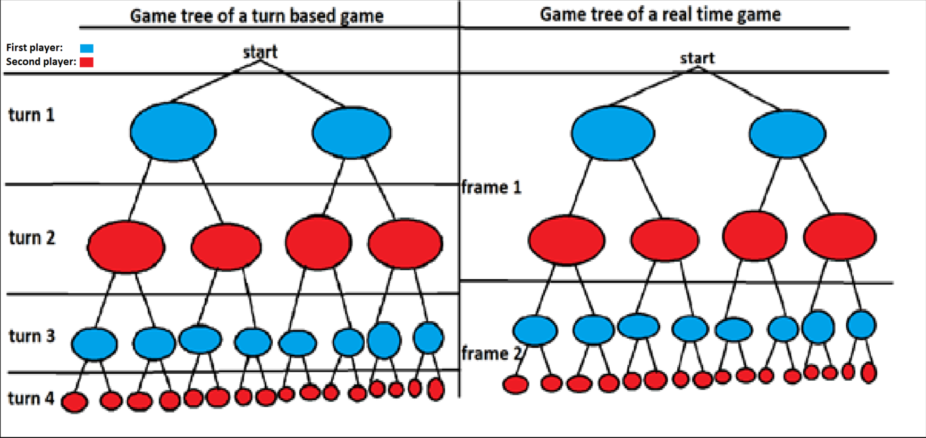

Therefore, for games that occur in RTS we shall use the following formula: $$GTC=b^{pd}$$

Where *‘p’* is the number of players in the game.

Open AI developed an algorithm that defeated the current world champions of an RTS game called DOTA 2 in 2019. DOTA 2 is played by 10 players although these players are divided into 2 teams that each have the same goal so for the purposes of evaluating positions it can be considered a 2-player game. “Dota 2 games run at 30 frames per second for approximately 45 minutes” which means that the duration of the average game is 81,000. Open AI calculated that “there are an average of ~1,000 valid actions each tick” per agent meaning there is a branching factor of 10005 for each team. There are 2 teams, so the game has a GTC of 1000810,000.

<https://arxiv.org/pdf/1912.06680.pdf>

<https://openai.com/blog/openai-five/>

DeepMind developed an algorithm that “ranked among the top 0.2 percent of human players” in an RTS game called StarCraft. StarCraft had already been a target of AI research by then and in 2013 researchers had calculated “that typical games last for about 25 minutes, which results in d ≈ 36000 (25 minutes × 60 seconds × 24 frames per second)”, that “the branching factor would be between u50 and u200, where u is the average number of actions each unit can execute” and that, using a “conservative estimation of about 10 possible actions per unit per game frame” the branching factor would be “between b ∈ [1050 , 10200].” Assuming the possible values for *‘b’* are uniformly distributed we can calculate the average branching factor with the following formula:

$$\left(\frac{\sum_{i=50}^{200}{{10}^{i}}}{151}\right)$$

StarCraft is 2-player so the GTC is computed by:

$${\left(\frac{\sum_{i=50}^{200}{{10}^{i}}}{151}\right)}^{72,000}$$

yielding a GTC of approximately 1014,246,377.

<https://hal.archives-ouvertes.fr/hal-00871001/document>

<https://project.dke.maastrichtuniversity.nl/games/files/phd/SearchingForSolutions.pdf>

Each point on this graph is a game. The x value is the year that AI surpassed humans at the game and the y value is $\log_{10}{\log_{10}{GTC}}$ for that game. I used this value because otherwise the curve grows too rapidly and is uninterpretable. Despite this a linear curve produces an R2 value of 0.4182 so an exponential curve with an R2 value of 0.7276 is still more fitting.

Summary statistics

|  |  |  |
| --- | --- | --- |
|  | Year | Log10(GTC) |
| Maximum Value | 2019.666 | 14,246,377 |
| Minimum Value | 1952 | 5 |
| Range | 67.666 | 14,246,372 |
| Mean | 1999.487146 | 1,282,904.692 |
| Standard Deviation | 19.07762126 | 1.937005705 |

Check these values

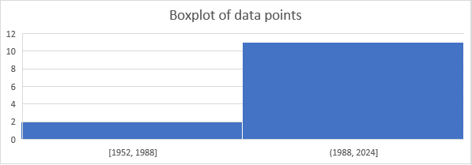

The boxplot shows a large gap between the first two data points and the rest coincides with the AI winter, a lull in AI research between 1980-2000. This alludes to the main problem with this data which is that its subject to interest. Only games that are commonly played for fun or seem like an interesting target for AI research are considered. This means there are very few games that fit as valid data points because an AI has not been developed to play them or due to lack of interest the time at which an AI was developed is not representative of the complexity of the game. For example, Shogi is considerably more complicated than Chess but not very popular outside of Japan. Therefore, it being mastered by AI 17 years after Chess, might not only represent the gap in complexity between the games but also the gap in interest. Alternatively, there is Arimaa, a game invented in 2003 and designed to be difficult for AI to master. Since its inception, the creator had offered a $10,000 reward to any AI that could beat a human top player creating an incentive for AI research around the game.

To predict when HLMI will be created, we need to estimate the GTC that the human brain operates in and then continue the trendline on our graph to this point and see what year the point falls at. To do this we will observe the capabilities of the human brain.

$$GTC=b^{pd}$$

The duration represents how far ahead one must think to evaluate a decision. Its possible for humans to think far ahead of their own lives depending on their goals but this is unlikely to be the case for most decisions and so, keeping in line with games we have analysed we shall assume the tree ends where one stops making decisions, at the end of their life. The global average life expectancy is 72.6 years.

A paper on brain state transitions estimated the number of daily thoughts humans have. “Extrapolating from our observed median transition rate across movie-viewing and rest of about 6.5 transitions/min, and a recommended sleep time of 8 h, one could estimate over six thousand daily thoughts for healthy adults.” <https://www.nature.com/articles/s41467-020-17255-9>

Therefore, we can estimate the number of layers in the game tree of life to be 453,024.

$\left(6.5× 60 × \left(24-8\right)\right)×72.6=$ 453,024

Until now we have only considered games with effectively two players but in real life there can be far more separate entities with separate goals however we only need to consider the number that will be factored into any given decision. An anthropologist named Robert Dunbar published findings that “suggest that there may be cognitive constraints on (social) network size” and estimated the maximum group size for humans to be 150. We can use this as a safe upper bound for our number of players, *p.*

The branching factor represents the number of possible decisions one can make in any situation. An article from the Encyclopaedia Britannica on information theory states that the brain has “an information capacity of less than 50 bits per second.” This means the brain can only process 50 bits of information at any given time. Each bit has two possible states therefore they can be arranged in 250 possible ways.

Therefore, the GTC of life can be approximately calculated with:

$${(2^{50})}^{150×453,024}$$

Resulting in a value of 101,022,803,595.

Now we can add this point to the trendline of our graph.

Assuming AI development continues at its current rate, this graph predicts that an AI capable of operating in an environment as complex as the real world will exist by July of 2037. This has significant implications for example in. Agent based modelling is a popular technique for analysing all kinds of human behaviour and this shows it could reach a similar level of accuracy to real world empirical methods in the near future. This also adds credence to the simulation theory proposed by Nick Bostrom. This argues that we live in a simulation and one of its axioms is that humanity will be capable of running “high-fidelity ancestor simulations”. More generally, this data visualises the rapid pace at which AI is improving and indicates that concerns about AI safety should be taken more seriously.

The estimate produced is not to be used with any certainty, but it acts an approximate guide to AI progress. This method may be more reliable in future if there are more data points for the graph and we have a better understanding of the human brain.

https://www.simulation-argument.com/simulation.html